**DATABASE MANAGEMENT SYSTEM MINI PROJECT**

**(SPACE DATABASE)**

TEAM MEMBER DETAILS

NAMES : PRANAV AMBIG

SRN : PES1UG21CS434

NAME : PURAB NAGARAJ

SRN : PES1UG21CS459

SECTION : 5H

**SPACE DATABASE ER-DIAGRAM**

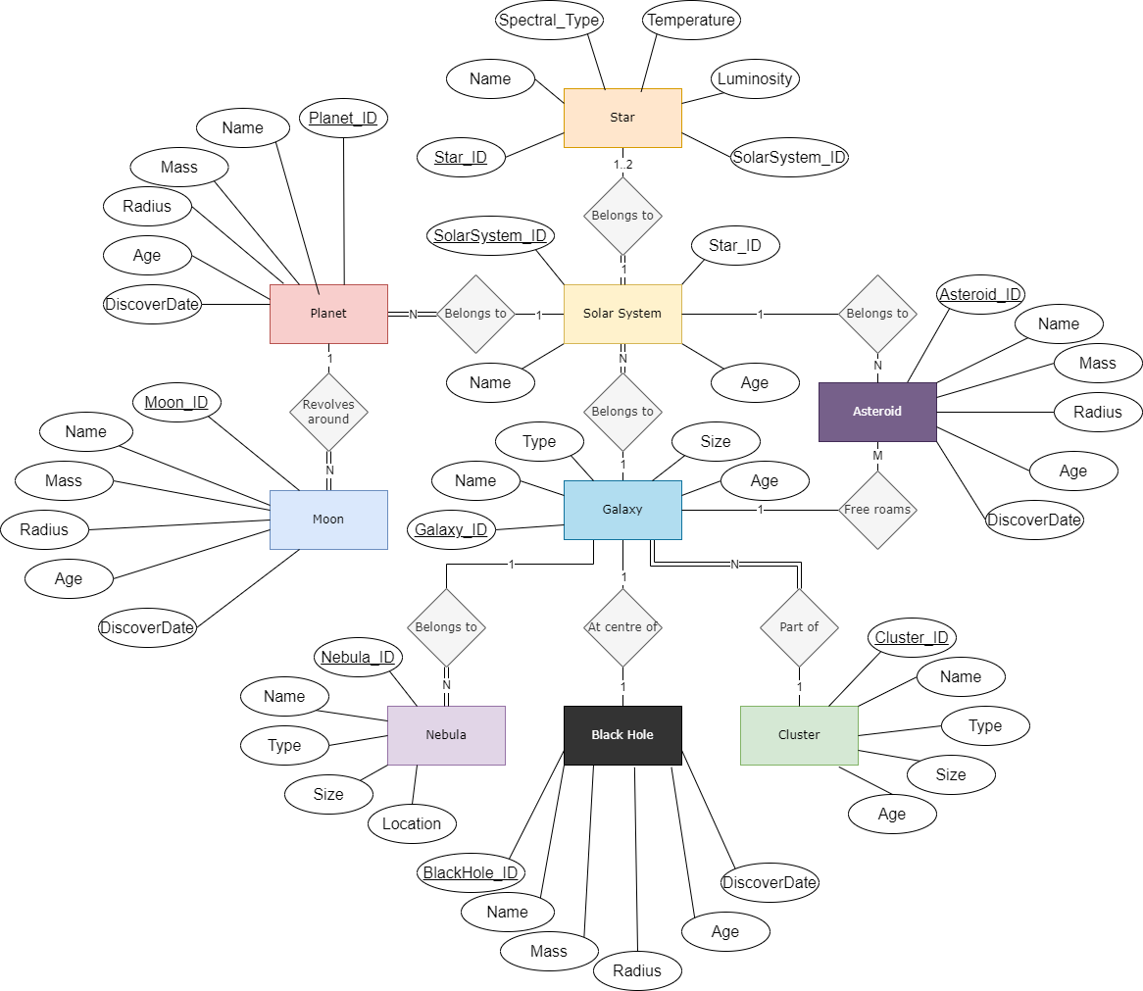

**SPACE DATABASE RELATIONAL SCHEMA**

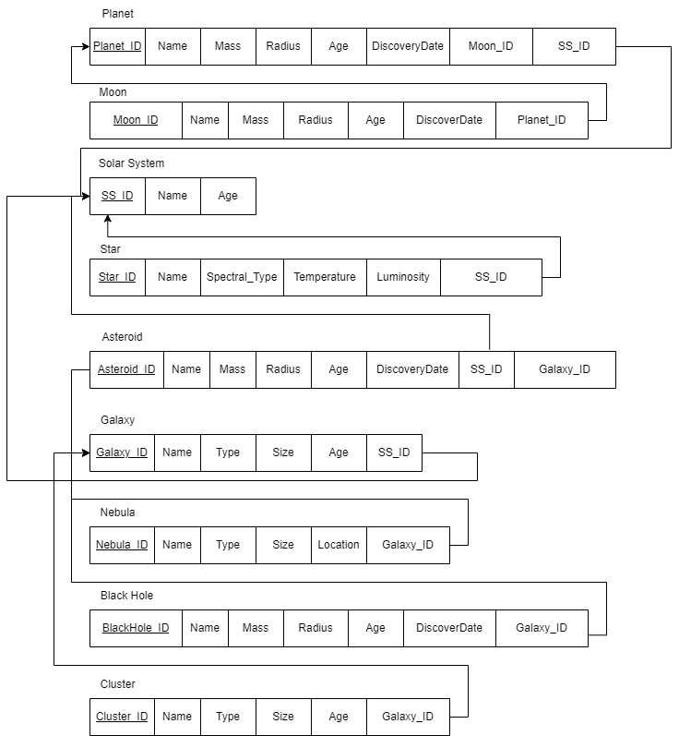

**SPACE DATABASE USER REQUIREMENTS**

The user requirements for a space database are as follows:-

* Astronomical research and modelling.
* Education and outreach for teaching and popularizing astronomy.
* Planning observations for amateur astronomers.
* Providing information and inspiration for space enthusiasts.
* Supporting mission planning and space exploration for space agencies.
* Data analysis, visualization, and communication of astronomical concepts.
* Accessing historical records of astronomical observations.
* Decision-making and space debris tracking for government agencies.
* Supporting space engineers and spacecraft designers.
* Enabling contributions from citizen scientists and amateur astronomers.
* Facilitating research in astrobiology and habitability studies.
* Monitoring space weather and cosmic rays for environmental research.
* Inspiring creative works and art related to space and astronomy.